

Text Box

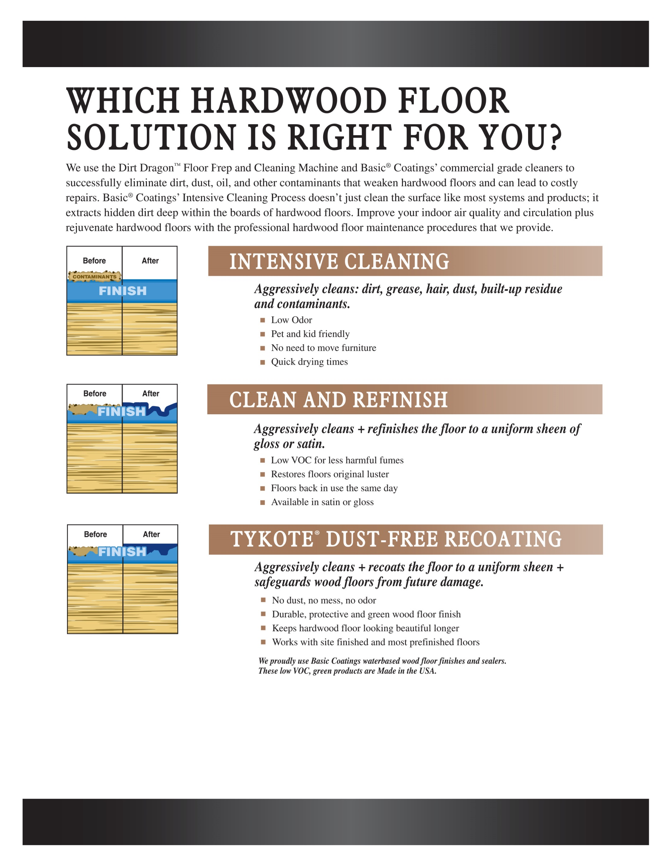

Your company

Your address

Your City, State Zip

Phone Number

Website